Elizabeth Caden Invitational
When: January 3, 2026 --Deadline: December 6, 2025
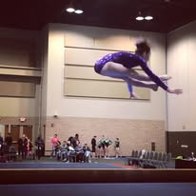
Where: Tri-Star Gymnastics 1401 Circle Ave, Forest Park, Illinois 60130 Phone: 708-771-7827
Contact: coachlynnusag@gmail.com - Equipment: AAI - Admissions: $10.00- Parking: Street
Entry Fee: $150 All Levels 4-10 and Xcel (Payable to Tri-Star Gymnastics)
Session 1: 8:30 Check-In 9:15 warm-up/compete. Session 2: noon Check-In 1:00 Compete
Session 3: 2:45 Check-in 3:30 Compete
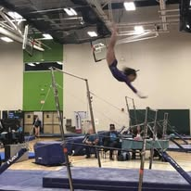 Space is Limited 



